An FFT-based technique for fast fractal image compression
M. Ramkumar, G. V. Anand
Signal Processing 63 (1997) 263-268
Abstract
This paper presents a new FFT-based technique of fractal image compression which can significantly speed up the process of matching domain and range blocks.
- Introduction
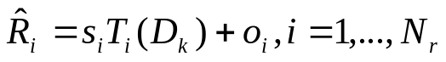
2. Error minimization
Let 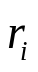be the zero mean range vector corresponding to the range block 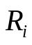, obtained by subtracting the mean value of from all the elements. Let 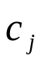 denote the zero-mean codebook vector obtained similarly from the codebook block 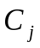.
For a given I, the codebook vector and the scalars 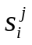and 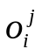so as to minimize the error
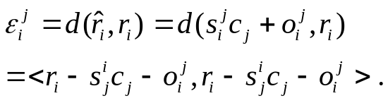
Since both and are zero-mean vectors, it is obvious that =0.
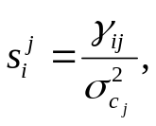
where
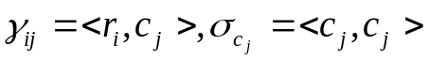

The error is now given by

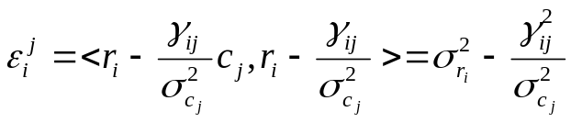
We just have to find the maximum of 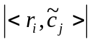, where 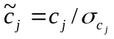
- FFT-based block matching
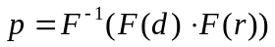
where F stands for DFT and 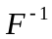stand for inverse DFT,and a dot between two vectors denotes their Hadamard product(the vector whose elements are obtained by multiplying the corresponding elements of the multiplicands).
- Implementation

Image | JM | FFT-NS | FFT-HS
Lena | 30.36 | 28.58 | 29.12
Baboon | 24.87 | 24.65 | 25.13
Boats | 30.05 | 28.25 | 29.13
Peppers | 31.85 | 28.56 | 29.45

Comparison of PSNR of decoded images for Jacquin’s method(JM), FFT-based block matching-normal scan(FFT-NS) and Hilbert scan(FFT-HS)
- Computational complexity
- Conclusion
Created by: Shin-Si Chen
Date: Jan. 22, 1999

